10/20/2014

NEW YORK CITY Fire Department

9 Metrotech Center

Brooklyn, NY 11201-3857

To Whom It May Concern:

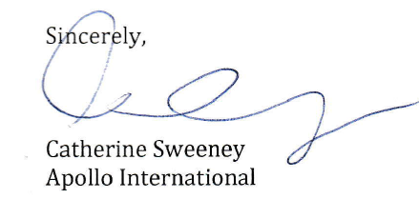We are pleased to sponsor our employee, Mr. Ernest Butcher for the Certificate of Fitness for (Z-50) CONSOLIDATED FIRE SAFETY DIRECTOR. Mr. Butcher is employed at 30th 7th Avenue New York, NY 10011. He has shown himself to be a conscientious individual and an excellent candidate for certification.